This video shows a small game console from Makey Makey. The right arrow keys control the right player's movements in the unity, and the left keys control the left player's movements. The remaining buttons are used to enter the game menu and start(/restart) the ping pong and target scene.

Finish with a conclusion
what went well when working on this project?
All buttons are working, so the console is fully functional.
what didn't go well?
There were some difficulties with setting up the buttons, since the function of switching buttons by keys in Unity stopped working for some reason, and it was also not immediately clear where to insert the code in the script to make it work, but in the end it worked.
what would you do differently next time?
more interesting design

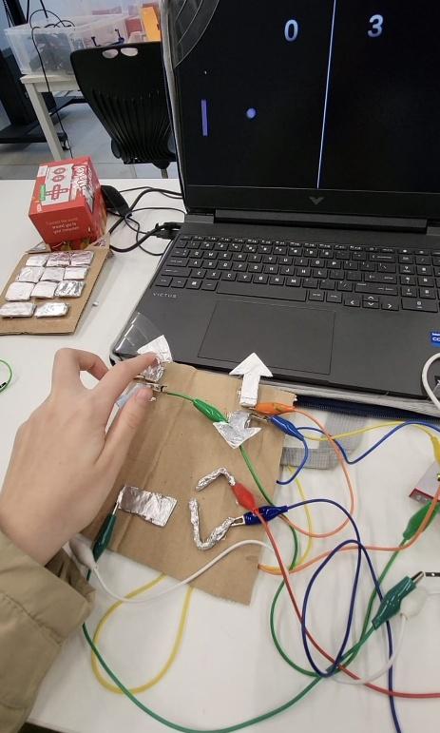
photo of someone interacting with your prototype

